GST F18: APPLICATION FOR REMISSION UNDER SECTION 89 OF THE GST ACT FOR REFUND OF IMPORT GST PAID ON BEHALF OF AN IMPORTER  TO: COMPTROLLER OF GOODS AND SERVICES TAX (“CGST”)  55 Newton Road Revenue House Singapore 307987  Enquiry telephone number: 1800-3568633 | 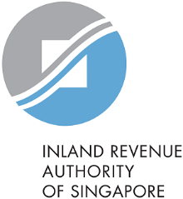
Declaration by Importer
I declare that I have not claimed and will not claim the import GST that my freight forwarder / logistics agent is requesting a refund of, as shown below.

Import permit number | Name of Importer on the permit | Importer’s Unique Entity Number (UEN) | Brief description of the imported goods | Value of the imported goods  (as shown on the import permit) | Amount of import GST paid | Date of GST payment
You may also provide the above details in a separate sheet.

Importer’s particulars:
Full name of importer:
Unique Entity Number (UEN):
GST Registration Number:

Details of authorised* person
*This declaration is to be made by the director, partner, sole-proprietor or authorised personnel.
Name of authorised person:
Designation: |  | Contact Number:
Email: |  | Signature:

