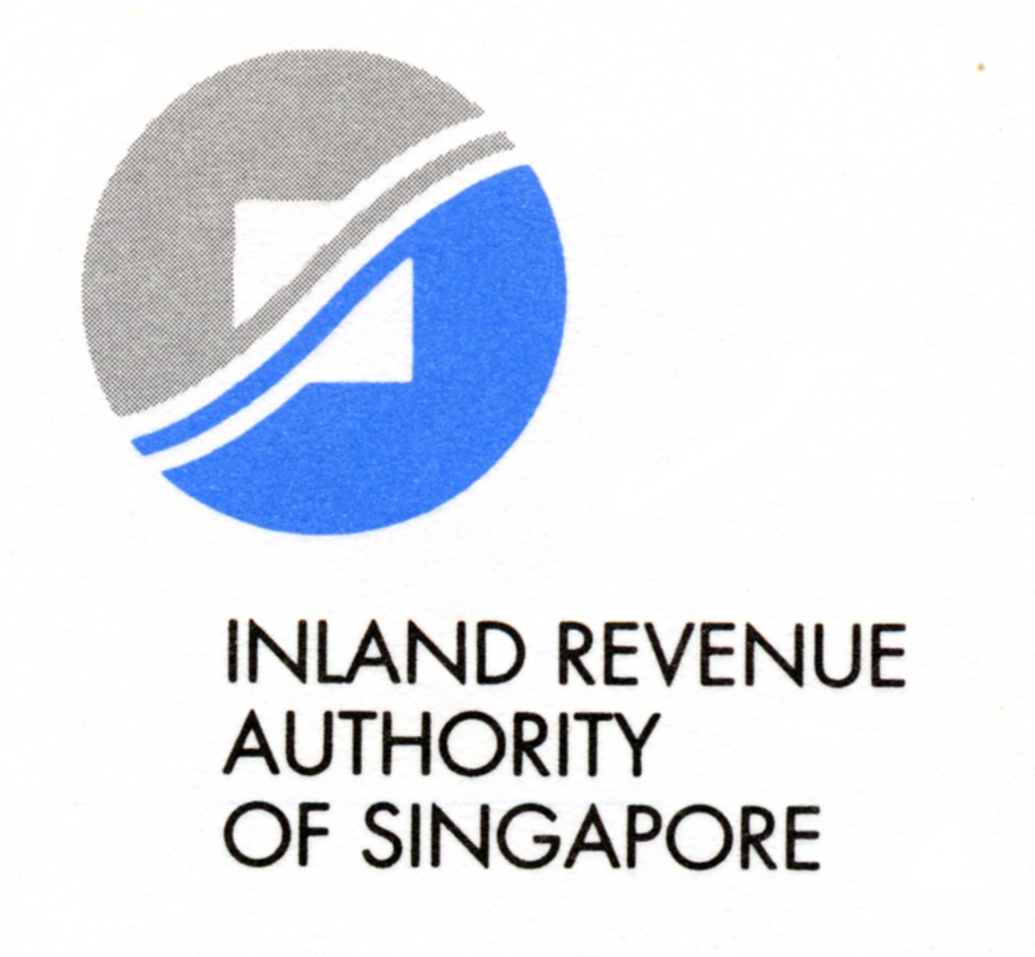
REQUEST FOR TAX REASSESSMENT FROM ‘NON-RESIDENT’ TO ‘RESIDENT’ STATUS
This form is to be completed by a foreign employee (excluding directors of a company and
public entertainers) applying for resident status

It may take you 3 minutes to fill in this form. Please get ready your letter of employment/work pass

Section A : Your Personal Particulars
Full Name (as in passport): | FIN / Passport No :
Address (For all correspondences): | Contacts:  - Email address___________________  - Tel ____________________________

Section B: Application for Resident Status
(Please attach a copy of the letter of employment / work pass from your current employer)

Please review my assessment for the year ____________ as I qualify to be assessed as a resident for tax purposes.

1. I have been employed by ___________________________________ (Name of current employer) with effect from ____________.

2. I have been physically present / working in Singapore for:

- 3 consecutive years from ________________ to __________________

- 183 days or more from __________________ to __________________

My schedule of days in Singapore is as follows:
(Please attach separate list if space is insufficient)

Year | Date of arrival | Date of departure# | No of days

Section C: Your Declaration
I, hereby declare that all information given in this form and in any documents attached is true, correct and complete.
Date
Signature

Under the Singapore Income Tax Act, there are penalties for making a false or incorrect declaration.

- Please tick where appropriate

CON CEN-OP-CTR-10/F02-06
55 Newton Road, Revenue House Singapore 307987 Tel: 1800-3568300 Fax: 6351 2707 Website: www.iras.gov.sg

